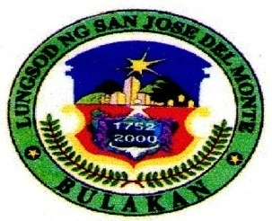

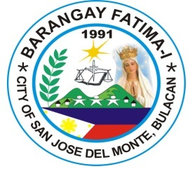

**REPUBLIC OF THE PHILIPPINES**

**PROVINCE OF BULACAN**

**CITY OF San Jose Del Monte**

**office of the PUNONG Barangay**

***#301 St. Jude St. Fatima I, City of San Jose del Monte, Bulacan, 3024***

Control No.: 421

TO WHOM IT MAY CONCERN:

This is to Certify that ______________________________,_____ years old is personally known to me being bonafide resident of _____ _________________ Street, Barangay Fatima-I, City of San Jose Del Monte, Bulacan since _______up to present. He/She has NO Criminal record nor has been charged of any Moral Turpitude in this Barangay.

This Clearance is being issued upon the request of the above person for whatever legal intent and purposes it may serve him/her best, particularly for:

______________________________

Issued this _____ day of __________ , 2022 at the Office of the Punong Barangay, Barangay Fatima-I, City of San Jose Del Monte, Bulacan.

**HON. GEORGE S. TABLAN, JR.**

Punong Barangay

*ATTESTED BY:*

Not valid w/o Dry Seal

Date: _____________

**MRS. CHARMAINE R. FADRIQUELA**

Barangay Secretary

Applicant:

**____________________________**

Signature Over-Printed Name

Res. Cert. No. ________________

Issued on: ___________________

Issued at: ___________________

NOTE: This Barangay Clearance is valid only for six (6) months period from the date issued.

**HON. GEORGE S. TABLAN, JR.**

Punong Barangay

Mga Kasangguni sa Sangguniang Barangay

**HON. LUZVIMINDA T. PAGCANLUNGAN**

**Chairman Committee on Ethics and Privileges /**

**Transportation and Communication**

**HON. REDEL T. DELFIN**

**Chairman Committee on Livelihood, Trade and Industry / Public Works / Patrimonial Property**

**HON. CRISTINA C. BALMORES**

**Chairman, Committee on Health / Land Use and Zoning**

**HON. AMBROCIO F. MILO, JR.**

**Chairman Committee on Education / Finance and Appropriation**

**HON. HENRY P. FIEL**

**Chairman Committee Woman and Family Relations / Tourism and Culture**

**HON. MYRNA D. PAILAGA**

**Chairman Committee on Sanitation, Beautification, Agriculture Environment & Natural Resources / Labor and Employment**

**HON. JAY MARK V. ESPAÑOLA**

**Chairman Committee on Peace & Order / Ways and Means / Bids and Awards (BAC)**

**HON. KENNETH T. SOLOMON**

**Chairman Committee on Youth & Sports Development / Human Rights**

**MRS. CHARMAINE R. FADRIQUELA**

**Barangay Secretary**

**MRS. VILMA S. CASTRO**

**Barangay Treasurer**

**MR. REYNALDO V. OCAMPO**

**Barangay Record Keeper (BRK)**

**MR. NOEL L. BIGOL**

**Barangay Administrator Officer**

**MS. HELEN A. SEELIN**

**Barangay Chief-Tanod**

**Right Thumb**